Valentin Stetsyuk, Lviv; Ukraine
Edited by Elena Romanova, Montreal, Canada

Introduction to the Study of Prehistoric Ethnogenic Processes in Eastern Europe

The lesson of history in this millennium now
drawing to a close shows that this is the path
to follow: it is necessary not to abandon the
passion for ultimate truth, the eagerness to search
for it or the audacity to forge new paths in
the search. It is faith which stirs reason to move
beyond all isolation and willingly to run risks so
that it may attain whatever is beautiful, good and true.

John Paul II

Encyclical letter Faith and Reason(56),
Rome September 14th, 1998

During almost 20 years I have been investigating prehistoric ethnogenic processes in Eastern Europe that were already partially described in my book.The main principle of my investigations was my own graphic-analytical method, as I named it and it was briefly described on the example of Slavic languages.The essence of this method is quantitative estimation and geometrical interpretation of common characteristics in cognate languages. The close language relationship is usually associated with the bigger number of words identical in their origin. This concept was established by linguists already at the end of the last century.That is why it was the lexical material that was mainly used in my work. The lexical-statistical methods were chosen for this study because lexical material has the advantage of being discrete and abundant therefore it easily lends itself for mathematical processing.
Many linguists consider language vocabulary as very unstable. This opinion can be explained by the fact that there is quite a lot of loan words in many languages. But it can be observed that loan words are those of more “cultural” level, but the oldest words which correspond with lower level of ethnical state, nevertheless, mostly remain in the language. These oldest words in the language are the ones which are the most frequently used. According to the opinion of Russian grammarian A.V. Desnitskaja, indigenious vocabulary includes a considerable part of the most frequent words which reflect elementary concepts and constitute the largest number of word-forming nests.”Other Russian linguists Arapov and Herts said the following about the correlation of the word frequency and its age:“There is correlation between the word’s frequency and the onset of the word’s appearance in the language... The majority of frequently used words are old words and vice versa, the lesser is the word frequency the more it is likely that this word is a neologism.”

The authors indicate that first this correlation was put forward by G. Zipf in 1947 and it was him who underlined its significance for the quantitative analysis of facts which had to do with the language history. However, it is necessary to consider that some words of small frequency can be old and that many neologisms can have high frequency but these newly formed words were removed from this lexical-statistical study because of their meaning.
The change rates of the basic vocabulary cannot be extremely high. M. Swadesh who specialized in the studies of changes in the lexical nucleus of languages, wrote that one can observe the difference in the vocabulary and in the word use of older and younger generations, but these differences do not extend to such level that they can cause mutual misunderstanding and it was this circumstance that limited the speed of the language change the most.No doubt that some number of words (though relatively small) disappears because of different reasons, but they often leave derivatives with remote but related meanings.
Under these circumstances, the words for this study with the application of graphic-analytical method were selected considering their high frequency or their reflection of elementary concepts. The analysis of the selected vocabulary was performed in accordance with the following theses:
First thesis - Language continuum.
Guided by the conclusions of certain scholars of the past we can assume that when some people settle on a vast and plain territory with no special geographical obstacles during the process of its cultural formation, at some point the increase of its vocabulary connected with these advances will eventuate in the development of isolated dialects from the language of this people. And these dialects will form such language continuum that will result in the differences between isolated dialects that increase monotonously and proportional to the distance separating certain ethnical groups as speakers of these dialects.
Almost ideal conditions for such language development according to the described scenario existed in plain Australia which is not crossed by big rivers. A Russian scholar V.A. Shnirelman describes the language situation in Australia: “Language continuum was characteristic for Australian aborigines, i.e. languages or dialects of adjacent groups demonstrated large similarity and their speakers understood each other well, whereas mutual intelligibility gradually disappeared with the distance between the groups.” If we graphically reflect the described language situation in our hypothetical territory of Australian type, it has the appearance of the line MS on figure 1.
Second thesis - Chronological stratification of the vocabulary stock.
If primitive people had their language with the total number of vocabulary units- Q from the outset of its settlement at certain territory, the new dialects continuum could develop in two ways: 1/ by the formation and interchange of new words among the dialects with the increase of Q in the language, 2/ by decrease of initial total Q in each dialect. But the both processes develop with different speed. The process of the formation and interchange of new words develops quicker than the process of decrease in initial total vocabulary. As the result, the entire vocabulary stock of each dialect can be divided into two layers - words derived from primordial language which we shall later name as the words of the first level and new words which we shall name as the words of the second level.
It is important to clarify this above- postulated correlation of the common words number and the distance between the dialects, as, in fact, it is influenced only by the words of the second level, because the words of the first level remain in approximately equal quantity at each time point in all the dialects.
Third thesis – Ethnogenic areas.
If the settlement territory of certain people, speakers of a certain language, has geographical barriers, that obstruct regular traffic and the contact of its groups, it will eventuate in the formation of more or less permanent settlement areas of these groups; then not language continuum but a certain number of isolated dialects will develop on this territory within such areas. And geographical barriers as wide rivers, mountain chains, big forests, swamps etc become the borders between such areas. So the number of common words in the languages of isolated groups decreases monotonously and proportional to the distance between their settlements within their areas but it decreases abruptly at the borders. It is possible to assume that more or less constant part of common words of the second level disappears at each intersection of the border. In that case the distribution of common words depending on the distance has the appearance of a broken line MTUVWXYZ on figure 1.
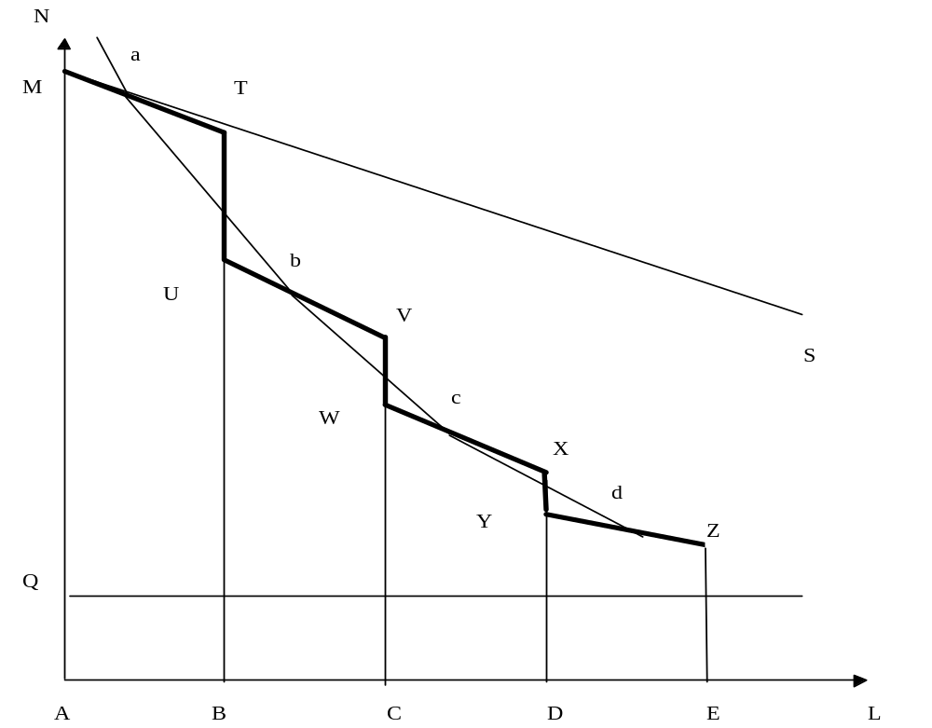

Figure 1. Distribution of the number of common words between dialects in areas, separated by ethnical borders.
N – the number of common words in dialects; L- the distance between the settlement areas; Q – the number of first level words common for all dialects; M – the total number of words in isolated dialect; AB, BC, CD, DE, – areas of isolated dialects.

This distribution has too complex mathematical expression. But if we agree to consider newly developed isolated dialects within areas AB, BC, CD, DE as separate language units, we can consider the distance between them to be equal to the distance between their area centres. Thus, if we connect the centres of segments MT, UV, WX, YZ, we obtain the distribution of common words in dialects as the line abcd. And if we move the origin of the co-ordinate from the point O to the point Q, we’ll see that the shape of this line in its central part will be close to hyperbola in its central part; therefore it can be described with the function of inverse proportionality y=k/x. In this case, the correlation of the number of words of the second level in the dialects and the distance between their settlement area centres can be approximately described with the formula M-Q = K/L, where K is the coefficient of proportionality.
Certain inaccessibility of settlement areas of isolated dialect speakers will eventuate in such difference between these dialects that they will transform into new languages which we shall call further the languages of the second level. These languages can develop again and form new languages of the third level, if the second level language speakers migrate to a new large territory. The combined complex of words of the first and second levels will remain in the languages of the third level. This process can continue further on. It can result in the conservation of the word complex of all languages of low levels in the languages of the higher levels, but only words of the highest level will be subordinate to the law of inverse proportionality, when the number of common words of this level depend on the distance between the ethnogenic areas of languages. Thus when we analyse languages of the higher levels, we should remove all the words of lower levels from the study, as a rule, such words are common for all analysed languages, and it considerably facilitates their exclusion.
Fourth thesis - The graphic model of mutual arrangement of cognate languages of the same level which reflects the disposition of settlement areas of its speakers can be built on the basis of the available lexical data. The performed theoretical calculations demonstrate that internal structure of lexical material of cognate languages can not be interrupted, even if its vocabulary was considerably distorted by borrowings and loss of some words.
Fifth thesis - It is possible to determinate for correct graphic model of mutual arrangement of cognate languages only one region on the map, and this region can be at the place of the formation of those languages. The surface of the Earth is so diverse that it is impossible to find similarly separated territories on it, so, if we can place this graphic model on a certain region at the map, it means that we can put it nowhere else. No change of map scale can modify this choice, because the change of the scale can’t produce similar large territories on the Earth. The connected centres of possible ethnogenic areas form complicated geometrical configurations with the shape of irregular polygons. For example, it is impossible to make a pentagon and a hexagon congruent, even if one changes their proportions and even distorts their forms to some degree.
Sixth thesis - The evolution of separate languages from a common primordial language starts simultaneously for all the languages, after the settlement of the peoples at the new territory if that is considerably bigger than their former area, and this development will be determinant for the later history of these languages.
Seventh thesis - Cultural advances and the migration of the people to new ecological conditions leads to the development of new words in its language.
***
The investigation of prehistoric ethnogenic processes required the analysis of large volume of lexical data selected from various dictionaries. It is not necessary to have perfect command of all these analysed languages when working with dictionaries of different language families, but it is indispensable to know their phonetic peculiarities and rules of their changes according to the requirements of comparative-historical linguistics.The work of H. Krahe when selecting and systematizing of words of Indo-European languages. The phonetic rules of Finno-Ugric languages were drawn from the book of Russian linguists Lytkin V.I. and Gulajev E.S. and the phonetic rules of Turkic languages were drawn from Baskakov’s classification.
The analysis was performed on the lexical level with the comparison of lexical units within two aspects - phonetic and semantic. The phonetic congruencies without semantic accordances were excluded from the study. The evaluation of semantic accordance was performed from synonymy, with more or less semantic similarity, till antonymy, which sometimes can be the consequence of concept characteristics (classical example - initial meaning of the word “edge” can change to “beginning” and “end”).
Nostratic, Indo-European, Finno-Ugric, Turkic, Iranian, Germanic, Slavic languages were studied with this new graphic-analytical method. Two types of table-dictionaries were used for each group of languages. At the beginning, the first type table-dictionary for the language group was composed, where the semantic list was placed in the far left column but all available synonyms of each semantic concept were placed in forthcoming columns for each analysed language. Then the obtained synonymic nests were analysed for phonetic similarity and it allowed us to select the isoglosses; the other words were added to the list after the analysis of synonyms with similar sense. The selected isoglosses constituted the table-dictionary of the second type where the identifiers of isoglosses were placed in the far left column and available correspondences from different languages were placed in the remaining columns. The data of these tables provided us with the means to calculate the number of common words in the language pairs, necessary for the construction of graphic models for the language relationships within the same language families. These graphic models are the graphs of specific sort, possibly yet to be described (the author has not yet found it in anywhere) in mathematics. This graph can be characterized as a “weighed graph” where not only single nodes but all of them without exclusion form mutual connections and not only the connection itself is important, the distance between all the nodes should be considered. In this case, each node of graph is not just a point but the aggregate of points and every aggregate correspond to a separate language in the relationship model. Each point of the aggregate is the end of the segment with the length inversely proportional to the number of common words in the pair of languages that correspond to those two aggregates connected by this very segment. When the number of common words in the language pairs is known, it is possible to determine the set of segments needed to build the graphic model. Even this possibility of the graph construction testifies the existence of a certain system in the database but certain doubts may arise. Let’s calculate this probability.
If we take the graph A, which has n mutually connected nodes, each node has (n-1) ribs. As we know from mathematics, it is enough to have only two co-ordinates in any frame of co-ordinates to place a point on a plane. For our graph, we can determine much more pairs of co-ordinates combining all ribs by two with each other. (When the length of ribs is known!). The number of pairs C can be calculated with this known equation:

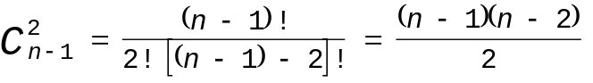

For example, if we have the number of nodes n = 6, the number of pairs C of co-ordinates will be 10, but when n = 10, C increases to 36, and C = 55 when n = 12. Thus if n is as much as 6, we can determine a place for each node in tens different ways. In our case with the graph A when we use all possible variants of nodes arrangement with the ribs of known length, every time some nodes will get to the same point. But when we analyse a real situation, for example, the system of cognate languages, the graph B, where each of its nodes is not just a single point but the aggregate of points, which fill small areas and these areas do not overlap each other, can meet our requirements. If we have the number of analysed objects n = 6 and they fill the area S = 1, each object fills the area as big as s =1/6. In that case, the probability for at least one point to get on its own place is equal to 1/6. If we have 6 objects, we can place each node in ten different ways (look above), so the probability for the point to get on the same very place in each of ten cases will be equal to 1/6¹⁰ = 1: 604 660 176. As far as we have 6 objects, this number should be multiplied by six times again and we shall obtain a number with 80 zeros in the denominator. If we have ten objects, the number of zeros in the denominator will increase up to 3600. It demonstrates that accidental construction of the graphical model is practically impossible.
Let’s illustrate the construction of the graphic model with Nostratic languages. The necessary material for the analysis was already selected and sistematized by Illich-Switych. He analysed lexical, word-formation and morphlogical similarities of six big language families of the Old World: Altaic, Uralic, Dravidian, Indo-European, Kartvelian and Semitic-Hamitic. The scholar asserted that these similarities can be interpreted only within the theory that postulates genetic relationship of these families i.e. that they belong to one wider group which he named Nostratic. Some of the results of his study were taken from the tables (morphologic features and the vocabulary of 147 units) and 286 lexical correspondences were found in the text of the book. After the comparison of this data with the research materials of another Russian scholar, consistent with the results of Illich-Switych, they were supplemented with 27 words from Uralic languages and 8 words from Altaic languages. As a result, it is turned out that we determined 433 features in total. Thirty four of them were common for all language families and the rest was composed of 255 units from Altaic, 255 units from Uralic, 253 units from Indo-European, 240 units from Semitic-Hamitic, 189 units from Dravidian and 139 units from Kartvelian languages respectevely. Then the number of common features in language pairs was calculated. The results of the calculation are given in table 1.

Table 1. Quantity of common features between language families.
Altaic - Uralic | 167 | Uralic – Kartvelian | 66
Altaic – Indo-European | 153 | Indo-European – Semitic-Hamitic | 147
Altaic – Semitic-Hamitic | 149 | Indo-European – Dravidian | 108
Altaic – Dravidian | 109 | Indo-European – Kartvelian | 70
Altaic – Kartvelian | 84 | Semitic-Hamitic – Dravidian | 110
Uralic – Indo-European | 151 | Semitic-Hamitic – Kartvelian | 86
Uralic – Semitic-Hamitic | 136 | Dravidian – Kartvelian | 54
Uralic – Dravidian | 134

We can’t yet speak of the certain rule in the analysed data but one can find out that as a rule there is the biggest number of common words in Altaic, Uralic, Semitic-Hamitic and Indo-European languages. Let’s try to build the graphic model of Nostratic relationship to prove the existence of a certain rule in this data. First, the distances between settlement area centres of separate Nostratic language speakers at the time of these languages development should be calculated with the formula L = K/N, when L is the distance, N is the number of common words in separate pairs and K is the scale factor. The choice of the scale factor is determined by the size of the plane we are building our model on. Number K = 1000 is consistent with our data. So the distances in cm between the areas of separate languages have the numbers presented in table 2.

Table 2. Distances between centers of language family areas at the diagram, cm.
Altaic - Uralic | 6.0 | Uralic – Kartvelian | 15.2
Altaic – Indo-European | 6.5 | Indo-European – Semitic-Hamitic | 6.8
Altaic – Semitic-Hamitic | 6.7 | Indo-European – Dravidian | 9.3
Altaic – Dravidian | 9.2 | Indo-European – картвельські | 14.3
Altaic – Kartvelian | 11.9 | Semitic-Hamitic – Dravidian | 9.1
Uralic – Indo-European | 6.6 | Semitic-Hamitic – Kartvelian | 11.6
Uralic – Semitic-Hamitic | 7.4 | Dravidian – Kartvelian | 18.5
Uralic – Dravidian | 7.5

The construction of the model requires reiterations. First, one point for each language is determined on two co-ordinates. These six points determine the estimated places of languages and their exact places are found with the subsequent iterations. In principle, one can start building the model from any language but when it is unknown in which direction it will extend it can exceed the limits of the plane. Therefore it is better to start with the language pair which has more common features. In this case, this pair is Altaic and Uralic languages. So, first, the segment AB with length of 6cm corresponding with the number of common words in these two languages is placed close to the center of the plane. The ends of this segment determine the place for points of Altaic and Uralic languages (see figure 2).

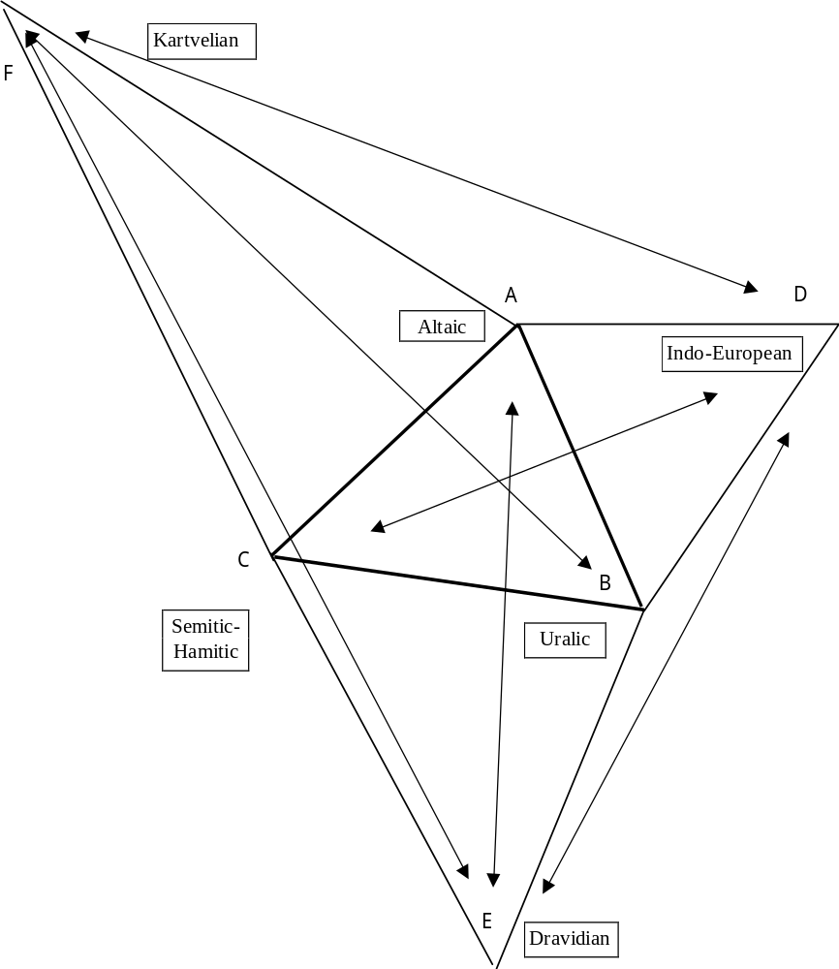
Figure 2. The first and the second iterations during the construction of the graphic model of Nostratic relationships.
The points for Indo-European and Semitic-Hamitic languages are placed on the base of this segment. We start with the point for Semitic-Hamitic because this language has more common features with Kartvelian and Dravidian. According to the number of common features the point of Semitic-Hamitic is to be placed at the distance of 6,7cm from the point of Altaic language, and at 7,4 cm from the point of Uralic language. Two arcs with such radiuses are made by the pair of compasses and the point of Semitic-Hamitic is situated on their attachment. There can be two of such points - to the left and to the right of the base AB. The first of them determines the final appearance of the graphic model that can have two mutually reflexive variants. We select the point closer to the center and obtain three points - A, B, C, and look for point D for the Indo-European languages. It is also situated on the base AB. It should be at the interval of 6,5 cm from the point A and at the interval of 6,6 cm from the point B. Two corresponding arcs are made with a pair of compasses opposite to the point C, so point D is found. (Point D can’t be close to the point C, for Indo-European and Semitic-Hamitic languages should have had considerably more common characteristics in such case, when it not like that in the reality). The point E for Dravidian languages is placed on base BC because Semitic-Hamitic and Uralic languages have the biggest number of common features with the Dravidian. Thus this point is placed at the interval of 7,5 cm from the Uralic point and 9,1 cm from the Semitic-Hamitic point in direction from the center of the model, otherwise it lies next to the Altaic point that is not consistent with the number of common features between them. The point F for Kartvelian languages is placed the same way but on the base AC. As the first iteration is finished, we can determine the scheme of the graphic model for Nostratic languages. The areas of these languages are to be somehow close to the points A, B, C, D, E, F. Then the positions of the language areas are corrected by building points on other bases. It goes without saying that new points do not overlap each other. The whole configuration of the aggregate of points for each language prompts us the direction where we should move the areas in order to be able to place the points to build the most compact graph. To do that we have to repeat two or three iterations. Finally, the model of Nostratic language relationship has the appearance presented on figure 3.
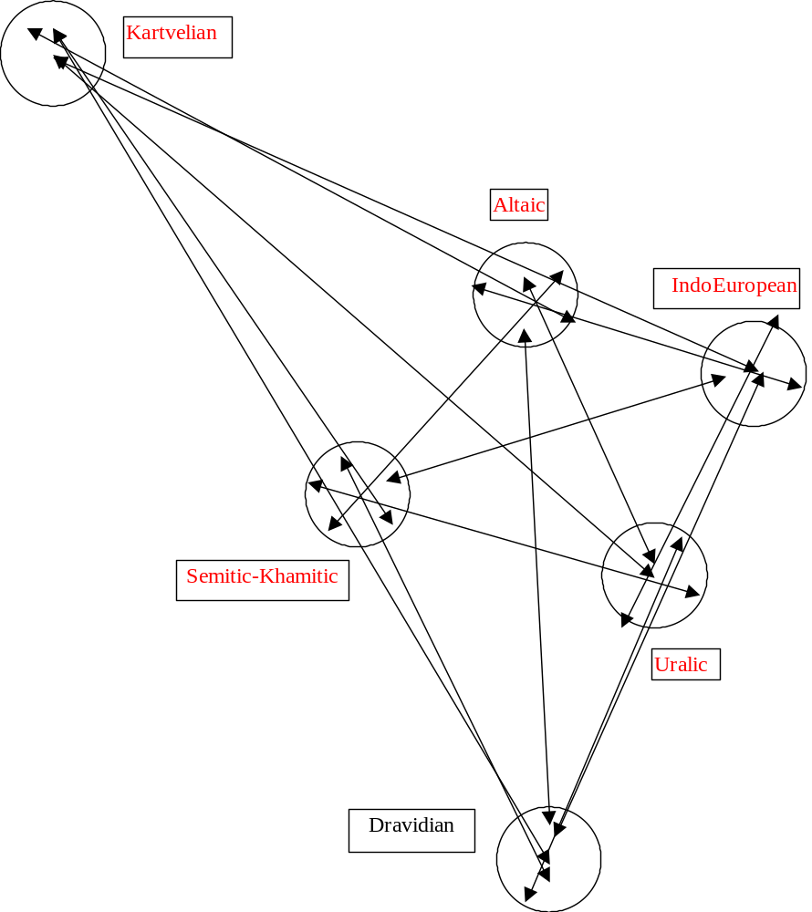

Fig 3. The model of relationship of Nostratic languages.

The method of the construction will be more understandable if you repeat it independently.
The next step is to find the corresponding region for this model, as the region of Fertile Crescent and Transcaucasia has central position to the present-day settlements of peoples of Nostratic language family, it should be somewhere in this region. Analyzing the map in detail considering the obligatory availability of geographic borders there is nothing more suitable than the territory near three lakes Van, Sevan and Urmia (Rezaye) - see map 1.

1.Map of Nostratic settlment areas
Legend: Drav. -Dravidian, Ind.Evr. - Indo-European, Kartv. - Kartvelian, Semit. - Semitic-Hamitic, Ural. - Uralic.

The fact that six (that is very significant!) modern independent states are situated in this region supports our opinion that these borders here are very well expressed. Three lakes form a regular triangle where the central part of our model can be perfectly placed. But as this triangle has regular shape, different variants of its arrangement are possible and immediately the problem of choice of the correct variant comes out. It is evident that Dravidian ancestors had to be settled somewhere to the South or to the East of the whole territory. Additional reason for the choice was, first, the fact that modern Kartvelians evidently live close to their old settlements and, second, the possibility of migration for Indo-European, Altaic and Uralic peoples to the North without obstacle must be considered. If we consider the reflexive variant, Kartvelians were to inhabit the territory to the North from what is now Azerbaijan on the slopes of Greater Caucasus, that should have made their contacts with the rest of Nostratic peoples impossible, in this case they should have been separated by still existing large swamps near the rivers Low Araks and Kura. Thus, accepting our model, Kartvelian predecessors covered the territory of what is now Georgia, to the South from Lesser Caucasus and a part of Armenian highland in the Chorokh and the Upper Kura river basins. Altaic ancestors dwelled near Sevan lake on the south slopes of Lesser Caucasus and probably at the other bank of the river Kura up to Aridag range and Ararat mountain. The Indo-Europeans lived to the East from Altaic people behind Zangezur range, probably at the territory of modern Karabakh and at the right bank of the river Araks up to the swamps to the East and the North. Uralic ancestors lived in the area near the Lake Urmia and Semitic-Hamitic peoples lived to the West from them near the Lake Van. Dravidian ancestors inhabited the region to the South from Semitic-Hamitic and Uralic people on the slopes of Khakiari and Kurdistan chains in of the Tigris, Great and Little Zab river basins. Later the population of this territory except the Kartvelians migrated to the new places of settlement, probably it took place at the beginning of the 5-th millenium BC.Now we’ll try to find these new areas analyzing the relationships of Indo-European, Finno-Ugrian and Turkic languages.
The table-dictionary for Indo-European languages was based on the etymological dictionary of the Indo-European language.These data were supplemented with words from the etymological dictionaries of other Indo-European languages.In total 2615 lexical isoglosses from Slavic, Celtic, Baltic, Germanic, Italic, Greek, Indian, Iranian, Tocharian A and B, Hitto-Luwian, Albanian, Thracian, Phrygian were placed into the table-dictionary. 489 isoglosses were admitted as common words. The words with the correspondences found in seven from eight of the most represented languages (Germanic, Greek, Baltic, Indian, Italic, Slavic, Celtic, Iranian) were considered as the common words. Calculation of the common words in the language pairs gave the results that are presented in table 3.
Table 3. Quantity of common words in pairs of Indo-European languages.
Languages | Slavic |  | Celtic |  | Germanic | Italic | Greek |  | Baltic |  | Indian |  | Iranian |  | Armenian
Slavic | 763
Celtic | 310 | 733
Germanic | 504 | 508 |  | 1217
Italic | 297 | 341 |  | 488 |  | 800
Greek | 403 | 406 |  | 637 |  | 509 |  | 1202
Baltic | 571 | 367 |  | 662 |  | 377 |  | 573 |  | 1059
Indian | 257 | 267 |  | 449 |  | 343 |  | 534 |  | 420 |  | 890
Iranian | 201 | 192 |  | 316 |  | 218 |  | 352 |  | 278 |  | 445 |  | 642
Armenian | 153 | 165 |  | 234 |  | 202 |  | 291 |  | 199 |  | 209 |  | 194 |  | 470

The total number of words for each language is given in the diagonal of the table. The number of common words for each pair of languages can be found on the intersection of the corresponding column and line. The data for Tocharian, Hitto-Luwian, Albanian, Thracian, Phrygian are not presented in the table because of small word numbers. The localisation of their areas in the relationship model of Indo-European languages is to be analysed later with the other methods. It should be taken into account that all the data presented here is current and is constantly being corrected while the new isoglosses are found, though these corrections don’t make much influence. The data oscillation of 5-7% does not modify the models at all, the correction leads only to more compact aggregate of points for language areas. The model of Indo-European language relationships was built in consistence with the above-mentioned method and is presented at figure 4.
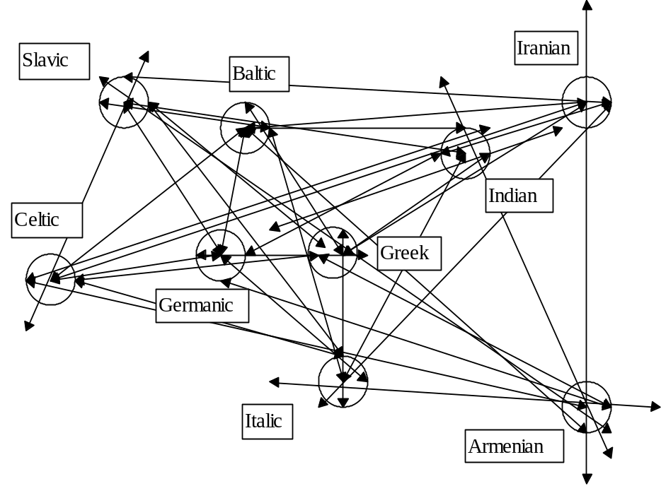

Figure 4. Graphic model of Indo-European languages relationships.

One of these two reflexive variants was chosen in order to be able to place Celtic area on the West, Iranian area − on the East and Baltic area − in the North. The reason for this choice is evident. When trying to place the model on the map of Eastern Europe where rivers can be considered as area borders, we determined only one suitable variant in the basin of the Upper and Middle Dniepr and its tributaries the Pripyat’ and Desna. All the Indo-European territory with separate areas for different languages is presented on map 2.

Map 2. Map of Indo-European settlment areas
Legend: Germ. - Germanic, Gr. - Greek, Ind. - Indian.

The lexical material for the table-dictionary of Finno-Ugric languages was mostly taken from bilingual dictionaries according to the semantic list of the basic vocabulary. The list was composed of the most frequent words (plants, animals, kinship terms etc.), the same as for the table for Indo-European languages. The etymological dictionary of Komi provided us with specially interesting data. Such Finno-Ugric languages as Finnish, Estonian, Veps, Komi, Lappish, Udmurt, Mari, Mordvin, Khanty, Hungarian and Mansi were analysed. There are 1624 isoglosses in the table-dictionary. 148 of them were common words. (The words found at least in ten from eleven Finno-Ugric languages were considered as common words). Calculation results of common words are presented in table 4.

Table 4. Quantity of common words in pairs of Finno-Ugric languages.
Languages | Finn. | Eston. | Veps | Komi | Lapp. | Udm. | Mari | Mord. | Khanty | Hungar. | Mansi
Finnish | 719
Estonian | 512 | 619
Veps | 421 | 389 | 537
Komi | 294 | 221 | 149 | 682
Lappish | 291 | 231 | 198 | 214 | 414
Udmurt | 251 | 206 | 139 | 531 | 168 | 666
Mari | 261 | 216 | 183 | 375 | 180 | 408 | 633
Mordvin | 271 | 243 | 233 | 249 | 154 | 264 | 312 | 502
Khanty | 192 | 152 | 106 | 309 | 145 | 277 | 238 | 162 | 518
Hungarian | 165 | 133 | 95 | 280 | 111 | 283 | 264 | 167 | 269 | 452
Mansi | 142 | 121 | 86 | 248 | 119 | 212 | 183 | 124 | 345 | 201 | 413

The model of relationships for Finno-Ugric languages was built on these data and is presented in figure 5.
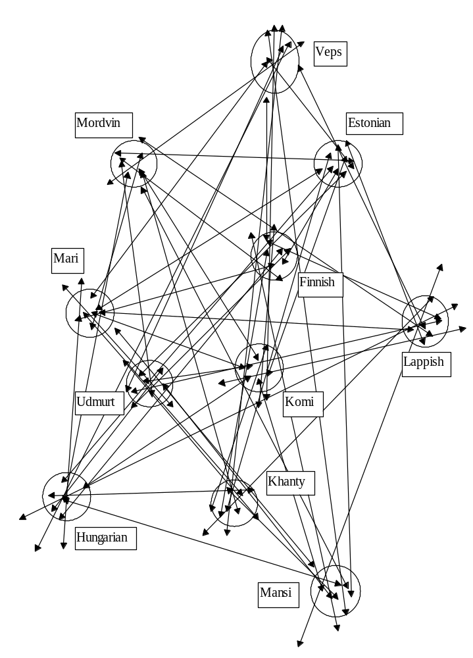
Figure 5. Graphic model of Finno-Ugric language relationships .

The corresponding territory for this model was found in the area between the Volga and Don and in the River Oka basin, where, according to the traditional opinion, the settlement of Finno- Ugric peoples was once situated, although initial Finno-Ugric land of origin is considered to be near the Urals (see map 3).

Map3. Map of Finno-Ugric settlement areas

There were certain difficulties when working with the Turkic family, namely the determination of the analysis objects. As it is known, this family is large, there are as many as thirty members including extinct languages. Some of them are so similar that one can assume their common origin from a language of lower level than Old Turkic. There are different classifications of Turkic languages consistent with each other in the recognition of closest relationships. Multi-level historical classifications of well-known turkologist Baskakov were used for this study.He divided several groups and subgroups of Turkic languages on the highest level. They comprise from one to five-six modern Turkic languages. If we unite close cognate modern languages of separate subgroups in one conventional language, we obtain only thirteen languages that can be considered as self-contained objects for this graphic analysis. Though two extinct languages as Old-Uighur and Karluk-Uighur could not be analysed because of the absence of necessary dictionaries. According to the genetic connections after Baskakov, conventional names were used for all Turkic languages taken for the analysis, sometimes identical to the modern names for some languages, but without claim to the historical accuracy and only for the convenience for the further narrative. Thus, in the further narrative, Bulgarian (Volga-Bulgarian) language corresponds with modern Chuvash and extinct Khazarian; Tartaric − with modern Tatar and Bashkir; Kipchak − with modern Kumyk, Karachai, Balkarian, Crimea-Tatar and Karaim; Nogai − with modern Kazakh, Karakalpakh and properly Nogai; Oghuz − with modern Gagauz and the dialects of Balkan Turks; Seljukian − with modern Turkish, Azerbaijani and south dialect of Crimean Tatars; Karlukish − with modern Uzbek and New Uighur; Tuba − with modern Tuvinian and Karagasian; Khakassian − with modern Kamasinian, Shorian, North-Altaic, Sari-Uighur, Language of Chulim Tatars and properly Khakassian; Altaian − with modern South-Altaic, but Kirghiz, Turkmen and Yakut correspond with proper modern languages.
The table-dictionary of Turkic languages was composed of the data taken from bilingual dictionaries but mostly from the etymological dictionary of Turkic languages.The quantities of common words in pairs of languages are given in table 5.
Table 5. The number of common words in pairs of Turkic languages.
Languages | Kirghiz | Nogai | Karl | Tartaric | Kipch. | Seljukian | Turkmen | Khakasian | Tuba | Yakut | Bulgarian | Oghuz | Altaian
Kirghiz | 870
Nogai | 744 | 870
Karluk | 686 | 704 | 861
Tartaric | 642 | 674 | 642 | 815
Kipchak | 588 | 611 | 599 | 623 | 760
Seljukian | 528 | 529 | 568 | 532 | 553 | 757
Turkmen | 519 | 532 | 580 | 515 | 530 | 557 | 734
Khakas. | 447 | 421 | 405 | 412 | 381 | 329 | 310 | 588
Tuba | 407 | 360 | 354 | 342 | 294 | 278 | 264 | 377 | 558
Yakut | 312 | 290 | 274 | 262 | 254 | 222 | 185 | 274 | 296 | 454
Bulgarian | 310 | 306 | 317 | 342 | 325 | 296 | 294 | 165 | 140 | 102 | 441
Oghuz | 258 | 258 | 283 | 268 | 300 | 367 | 338 | 149 | 111 | 88 | 182 | 401
Altaian | 408 | 382 | 370 | 369 | 313 | 313 | 232 | 321 | 278 | 205 | 157 | 123 | 467

Despite of later mutual influence of old genetic connections during long migration of Turkic peoples, the model of relationships was constructed. It is presented on figure 6.
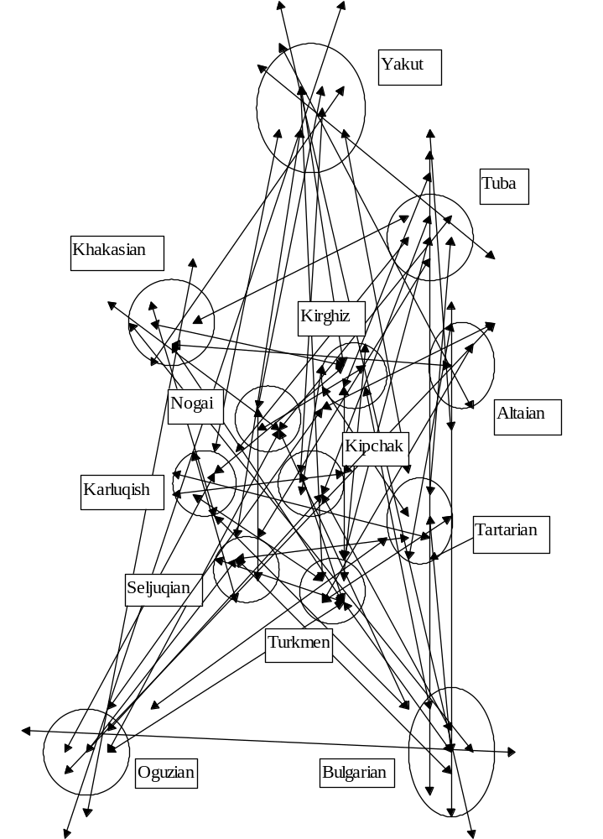
Figure 6. Graphic model of Turkic language relationships.

The attempts to place the model on the map near Altai region or in Siberia failed. The model can be put only in the region between the rivers Dniepr and Don where characteristic bend of the both rivers suggests us how to place the model (see map 4).

Map 4. The map of Turkic settlment areas
Legend: Gr. - Greek, Hng. - Hungarian, , Khak. - Khakassian, Oguz. - Oghuz, Tur. - Turkmen, Yak. - Yakut.

The fact, that ancestors of Indo-European, Finno-Ugric and Turkic peoples populated adjacent areas (Armenian and Gagauz, Veps and Iranian, Yakut and Hungarian etc)in Eastern Europe during certain period of time, can be confirmed by numerous correspondences in their languages.
The formation areas of the Tocharian, Hittite, Albanian, Thracian, Phrygian can be determined with the results of many scholars who investigated mutual relationships of Indo-European languages, supplemented with the data on settlement territories of Indo-Europeans and Finno-Ugrians. Let’s start with Tocharian. Many scholars believe that the first area of Tocharian settlement should be somewhere close to Greek, Baltic, Germanic settlements.They consider Tocharian area to be in the region of the rivers that flow in the Baltic Sea also because of the “salmon argument.” This fish spawns in the rivers of the Baltic Sea basin. There is a word related with Germanic, Baltic and Slavic words which means “salmon” in Tocharian, while this word is absent in the other Indo-European languages. There is a vacant area between the rivers Berezina and Dniepr close to the rivers of the Baltic basin that matches to all the requirements on the map. Tocharian area can be placed only here. According to the calculation, the number of common words in Tocharian and Greek is 146, and in Tocharian and Germanic - 145, in Tocharian and Baltic - 121, in Tocharian and Indian - 118. The number of common words in Tocharian and other Indo-European languages is considerably less. These results confirm the location of the Tocharian area between Baltic, Greek and Indian areas and close to the Germanic area.
And now − about the Albanian. Specialists have different opinions about its origin. According to Desnytskaja, many scholars consider Albanian as the successor of the Thracian or Illyrian.The analysis of lexical-statistical data and phonetic peculiarities allows us to speak about the evolution of Albanian from Thracian and that the ethnogenic area for Thracian took place between the rivers Desna, Seym and Oka.In that case, Albanian should have common lexical material with Mordvin, the area of which was adjacent to the Thracian area. Purposeful search of such vocabulary presents convincing results. Here are some examples of Albanian-Mordvin connections: Alb. anё “crocery” – Mord. en’a “scoop”; Alb. kapёrdij “swallow” – Mord. kapordams “swallow”; Alb. kofshё “thigh”– Mord. kacho “thigh”; Alb. keqe “evil” – Mord. k’azh “evil”; Alb. bizele “peas” – Mord. pizel “berries of mountain ash”; Alb. rroj “to live” – Mord. erjams “to live”. Some Albanian-Mordvin connections have parallels in other languages too: Alb. tani “today” – Mord. tjani “now” (Mari tenij “today”, Estonian täna “today”); Alb. dobёt “quiet” – Mord. topafks “sated” (Mari typ “quiet”); Alb. turi “muzzle” – Mord. trva “lip” (Mari tjarvö “lip” ); Alb. bretkosё “frog” – Mord. vatraksh “frog”(Greek βατραχοσ “frog”) etc.
Very little lexical data is available for the localization of the ethnogenic area for the Illyrian, but, according to the other language facts, Porzig found arguments to claim that Illyrian and Celtic areas were adjacent in early history.He also indicated that “Illyrian and Greek have remarkably little mutual connections though the both peoples lived in permanent proximity since the commence of Illyrian migration.”If we suppose that Illyrian area was near the Celtic and far from the Greek, we can find some additional data to prove the location of Illyrian area somewhere in the West of the Indo-European territory. Toponymic facts can very helpful in this case. The Illyrian toponymy was studied by linguist Trubachev and archaeologist Telegin. Pointing out at the relative vicinity of Celtic and Illyrian onomastics in general, Trubachev writes: “…hydronyms with West-Balkan connections are concentrated on the Dniestr narrow space and are sporadic to the North in the Goryn river basin and to the North-East in the Teterev river basin.”Telegin confirms this idea and specifies that Illyrian (Celtic-Illyrian) hydronyms make three concentrations in the Ukraine: Kiev, Zhytomir and Upper Dniestr concentrations. When the first two have only ten names, the last one has almost 30 names. Thus we have the reason to believe that Illyrian people lived in the Upper Dniestr river basin and populated the territory to the North at certain epoch. Their ancient area could be in the region between the rivers Sluch, West Bug and Pripyat’.
The ethnogenic area of Phrygian language was to be close to Greek and Armenian areas because the vicinity of Phrygian to Greek and Armenian is confirmed by numerous linguistic data. For example, Gamkrelidze and Ivanov wrote: “Phrygian language... has structural features that bring it close to the dialects of Greek-Armenian area.”Armenian scholar Kapantsyan indicated that Greek annalists (Herodotus, Eudoksus and others) were writing about the vicinity of Phrygians and Armenians. ”Phrygians and Armenians were together under the same banners in the army of Xerxes and they were dressed and armed identically.”Russian scholar Moisejeva also wrote about closeness of Phrygian to Greek and Armenian.Hirt and Lehr-Splavinski had similar opinion on this problem even earlier. According to this state of affairs, the area between the rivers Desna and Iput’ suits the best as the ethnogenic area of the Phrygian.
The number of common words in Hittite and other Indo-European languages suggests that the ethnogenic area of this language could be situated near Greek, Italic and Armenian areas.There are 80 Hittite correspondences in Greek, 78 - in Armenian and 58 - in Italic. Thus, Hittite area was to be in the triangle-shaped region among the rivers Dniepr, Teterev and Ros’.
The localised territories of settlements for ancient ethnical groups can be associated with the certain archaeological cultures well-known to the specialists of the Eastern Europe. For example, the Dniepr-Donets Culture can be associated with the Indo-Europeans. This culture emerged on the left banks of the Dniepr and in the Donets valleys in the 5th-millenium BC. The region of this culture “covers the Dniepr valley (from the modern town of Rogachev up to the banks of Kakhovka Reservoir), East Volyn, the Middle and Low Pripyat’, the Sozh, the Desna, the Vorskla, the Psel, the Sula and also the Middle Donets.”As we can see, this territory is almost identical with the Indo-European territory, if we point out that migration of bearer of this culture can be indicated from the Southeast to the Northwest.
A numerous group of Dimple-Comb Ceramics Cultures well-known in the Volga-Oka river basin existed simultaneously with the Dniepr-Donets Culture. Some tribes of these cultures entered the valleys of the rivers Seym, Desna, Psel, Sula and Donets and reached the region that nowadays is the suburbs of Voronezh and Tambov cities.This territory is almost the same as the localised territory for the ancient Finno-Ugrians. The Dimple-Comb Ceramics Cultures were the descendants of local Mesolithic cultures but ceramic manufacture was brought there from the outside, probably from the South. So we can presume that these cultures can be associated with Finno-Ugric tribes.
As for the Turks, we have all the grounds to associate them with the peoples of Seredniy Stoh (Sredniy Stog in Russian) culture who drove out the Indo-European tribes and occupied their old territory, expanding it to the borders, that we formerly located for the Turkic family. “As many as 100 known artefacts of Seredniy Stoh culture evidence that it covered the steppe region between the rivers Dniepr and Don, the southern part of forest-steppe of the Left-bank Ukraine, and the banks of the river Low and Middle Don.”
According to the archaeologocal data, the economics of Seredniy Stoh culture had stock-breeding character, mostly horse breeding. Horses formed as much as 50 % of heads of life-stock according to the number of bones found at the excavation of some settlements.Extensive development of horse-breeding among Turks from the earliest time can be also confirmed by the lexical data, as there are two words to name the horse among common Turkic words (moreover, separate words for the mare and stallion), there are common words for the horseman, bridle, stirrup, whip, mane, hoof, i.e. horse-breeding lexicon is perfectly represented in the common Turkic vocabulary. The wild horse was widely spread in the steppes of the Ukraine even at Herodotus’ time, thus we have all arguments to suppose that the Turks were the first who domesticated the horse, and it took place at the territory of modern Ukraine.
Different opinions exist about the chronological frontiers of Seredniy Stoh Culture. Ukrainian archaeologists date it from the beginning of the second half of the 4-th millennium BC till the end of the first quarter of the 3-rd millennium BC, but M. Gimbutas considers it thousand years older. But the most important fact is that its bearers are well identified with Turks and further we shall consider the population of the territory between the rivers Dnepr and Don from Sea of Azov to forest-steppe, as of Turkic origin and of European anthropology.
Many scholars believe that the Pit Culture developed on the basis of Seredniy Stoh Culture. Therefore we can consider its bearers as ancient Turks. The Pit cultural-historical region was the first unity of tribes in early bronze epoch of Eastern Europe, associated with territorial integrity of the population, predominance of common genetic components in the development of material and spiritual culture (the shapes of pottery, their decoration, funeral rituals), similar level of social-economic development, semblance of religion symbols and the system of social relations. According to the other opinions, Pit Culture had three stages of development and should be related to the Copper Age because it ceased its existence with the beginning of the Bronze Age. Radiocarbon analysis dates its latest stage at 25-19 century BC.
Progressive increase of the population compelled Turks to force their peaceful agricultural neighbours at the right bank of the Dniepr to the forest-steppe and even to the forest zone where they advanced along river valleys. The borders of the Pit Culture expansion reflect this migration process.“The territory of the expansion of the Pit Culture artefacts is quite extensive. They can be found in the East of Orenburg region, near Magnitigorsk city, on the banks of the river Emba. Its southern border goes along the river Terek and along all shores of Azov Sea and in Crimea. There are known artefacts in forest-steppe and they cover Samara bend, the Upper Don and Kiev city on the Dniepr. Western border ends on the region between the rivers South Bug and Dniestr.”
But the main direction of Turks migration was eastward. They advanced to the Caspian Sea across the steppes of the North Caucasus and then, using sledge in winter, crossed the Volga and began to settle in immense steppes of Kazakhstan and gradually covered large steppe spaces of South Siberia up to the Altai mountains.
Certainly, not all Turks left the territory of Eastern Europe, some of them stayed there and first of all Old Bulgars. Karl Menges indicated that there are few Altaic words in Chuvash language.Only Chuvash is distinguished from the rest of Turkic languages by peculiarity of the well known phonetic passage r, l → z, s/š. Probably, Proto-Bulgars crossed the river Dniepr and stayed in the steppes of the Right-bank Ukraine that can be proved by their language contacts with Old Italics. The facts of the lexical coincidences in Latin and Chuvash (sometimes also found in the other Turkic languages), that have no conformities in other Indo-European languages confirm this opinion. Here are some of examples: Lat. alga “alga, seaweed” - Chuv. yălkha “ooze”, Lat. altus "high, tall" – common Turkic alt “low” (inversion of idea); Lat. amicus “friend” – Chuv. dial. ami “friend”, “brother”; Lat. casa “house” – Chuv. kasă “street”; Lat. cito “quickly” – Chuv. khytă, Turkmen gaty, Kumyk qaty, Tataian katy – “quick, fast”; Lat.Cocles namely “crooked” - Chuv. kuklek “crooked”; Lat. codex “trunk”, “stump” – Gagauz k’at’ak, Azerbaijani kötük “stump”; Lat. fаbula “rumour” – Chuv. pavra “to chatter, to talk”; Lat. farnus “ash” (tree) – Chuv. věrene “maple”; Lat. imber “dense rain” – Chuv. c’umăr, Kazakh. janbyr, Uzbek. yomgyr “rain”; Lat. macto “glotrify” – common Turkic *mak,ta “to praise” (Chuv. mukhta, Kumykian makhtau, Tuvinian maktal, Tat. maktanu, Kaz. maktan etc); Lat. pиdis “louse” – common Turkic *bit “louse” (Chuv. pyyta” “louse”); Lat. saliva “saliva” – Chuv. sěleke, Az. selik, Kaz. selekey “saliva” etc, Lat. scopo “to sweep” – Chuv. šăpăr “broom”; Lat. sollicito “to shake” – common Turkic *sil- “to shake” (Chuv sille, Gag. silk, Turkm. silkedemek etc.); Lat. torta “round loaf” (from tortio ← torqere “twist”)- Chuv. tărta “to nest”, “to twine”; Lat. (Sabinian) teba “hump”, “mountain” – common Turkic *depe “mountain”; Lat. torus “height” – Chuv. tără “summit”.
When Turks left their territory the migration of Indo-Europeans followed. Celts, Illyrians, Italics advanced to the West. Old-Indians went to the Southeast, but Iranians remained in Eastern Europe for a long time. We know that Old-Iranian language had developed into many languages of higher level with complicated relationships. Now there are such Iranian languages: Ossetic, Yagnobi, Pushtu, Munchanian, Parachi, Ormuri, Yazgulamian, Shungan-Rushanian group, Ishkashimian, Vakhanian, Persian, Tadzhik, Kurdish, Beluchi, Talishan, Gilanian, Mazendaranian, Kumzari, dialects of Phars, small languages of Central Iran, Luri and Bachtiar dialects. Sogdian language disappeared but as Yagnobi is its successor therefore they can be united into one language. Iranian tribes of Sackes and Massagetes were in existence in the 1-st millennium BC. But it is still unknown what languages they were speaking. Thus it is very difficult to investigate the relationships of Iranian languages. However, comparative analysis of Iranian vocabulary was performed using Historic-etymological dictionary of Osseticand bilingual dictionaries of the following languages: Ossetic, Kurdish, Talishan, Gilanian, Persian, Pushtu, Tadzhik, Dari, Yazgulamian, Shugnanian, Rushanian (with Khufish), Bartangian, Yagnobi, Sarykolian. As it was found during the analysis, Dari language developed on the basis of Persian and Tadzhik and the latter evolved from Persian therefore all these three languages can be considered cognate. Common origin can be also found for Shugnanian, Rushanian and Bartangian. They were united into one group of Pamir languages. In total 1659 isoglosses were included into the study. 277 of them were considered as common Iranian words. Then the table-dictionary was composed and the number of common words in the language pairs was calculated. The result of the calculation is given in table 6.
Table 6. Quantity of common words in pairs of Iranian languages
Languages | Ossetic | Kurdish | Talishian | Gilanian | Pers. | Pushtu | Yazgulamian | Pamirian | Yagnobian | Sarykolian
Ossetic | 433
Kurdish | 219 | 602
Talishian | 111 | 240 | 430
Gilanian | 88 | 215 | 187 | 403
Persian | 200 | 360 | 260 | 312 | 732
Pushtu | 169 | 262 | 184 | 209 | 429 | 574
Yazgul. | 95 | 142 | 92 | 108 | 195 | 172 | 397
Pamirian | 122 | 187 | 123 | 165 | 286 | 341 | 274 | 535
Yagnob. | 176 | 184 | 141 | 151 | 269 | 215 | 162 | 222 | 463
Sarykol. | 67 | 105 | 79 | 94 | 147 | 122 | 149 | 229 | 126 | 321

These data let us to build the model of Iranian relationships presented on figure 7.
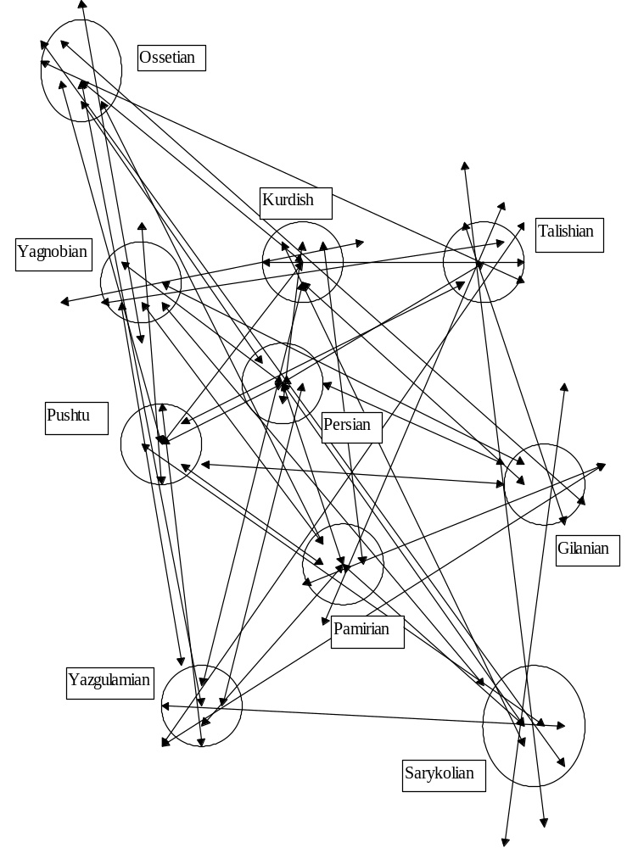
Figure 7. Graphic model of Iranian languages relationships.

Since Ossetians were the last who left their land of origin, this model of relationships was placed so that Ossetic area overlapped Old-Indian area in the Sozh river basin in the region between the rivers Dnepr and Iput’ i.e. on the remotest areas from each other (see map 5). Yagnobian area was placed in the region among the rivers Iput’, Dniepr and Desna, Kurdish area found its place between the rivers Desna, Seym and Upper Oka. Pushtu language had its area among the Dniepr, Sula and Desna as the other Iranian languages were placed among the tributaries of the rivers Dnepr and Don. Perhaps Old-Iranians covered all the territory between the Dnepr and Don and had formed Catacomb Culture which was spread in that region. But there are more “vacant” areas in the region between the Dniepr and Don. The ethnogenic areas of Iranian languages which are still to be analysed could be there. So, for example, Beluchi or Mazendaranian area, from the same language group with Kurdish, Talishan and Gilanian could be situated northward from the Kurdish area in adjacent to the Veps area. This supposition can be supported by available common words in Veps and one of these Iranian languages. Unfortunately the analysis of neither Beluchi nor Mazendaranian vocabulary could be performed. Instead, Veps vocabulary was analysed in comparison with the other Iranian languages. It turned out, that Kurdish had the biggest number of common words with Veps - 76, the runner-ups are Ossetic - 65 common words, Talishan - 61 words, Gilanian - 56 etc. As one can see, Kurdish and Ossetic area is situated the nearest to the Veps area and therefore there should have been the closest language contacts among the population of these regions.
Here are some examples of Kurdish-Veps lexical connections: Kurd çerk “drop” – Veps. čirkštada – “to drop”, Kurd. hebhebok “spider”– Veps. hämähouk – “spider”, Kurd. xumari “darkness” – Veps. hämär “twilight”, Kurd. kusm “fear” – Veps. h’ämastoitta “to fear”, Kurd. henase “breathing” – Veps. henktä “to breathe”, Kurd. hîrîn “neigh” – Veps. hirnaita “to neigh”, Kurd. e’ys “joy” – Veps. ijastus “joy”, Kurd. cirnî “trough” – Veps. kurn “gutter”.
Kurdish and Talishan areas were adjacent to Mordvin area. According to this, these languages have the biggest number of common words with Mordvin really.
Old-Germanics remained near the land of their origin though considerably expanded their territory. Nowadays there are almost ten Germanic languages divided into three groups. Danish, Swedish, Norwegian, Icelandic and Faroese belong to the northern group. English, German, Dutch and Frisian compose the western group. Extinct languages − Gothic, Burgundian and Vandalian belong to the eastern group. But according to F. Maurer, Germanic tribes were initially divided into five groups: Northern Germanics (ancestors of modern Danes, Swedes, Norwegians, Icelanders); Eastern Germanics (Vandals, Burgundians, Goths); Elbe Germanics (ancestors of contemporary Germans, i.e. Semnons, Suebs, Quads, Markomans, Hermundurs, Longobards); Rhine-Weser Germanics (ancestors of contemporary Dutches and Flemish); North Sea Germanics (Anglos, Saxons and Frisians) It is supposed that common language for all Germanic tribes existed till the 3-rd century AC and its division took place after the migration of Germanics into the Central and North Europe But the analysis of Germanic languages with the graphic-analytical method brings us to absolutely different conclusions.
According to the initial division of Germanic languages, mainly five languages, English, German, Dutch, Swedish and Gothic were used in the study. The table-dictionary was composed on the basis of these languages using the data from the etymological dictionaries of German, Gothic and also bilingual dictionaries. In total 1657 isoglosses were analysed. 726 of them were admitted as common Germanic words. The number of common words in language pairs is presented in table 7.

Table 7. Quantity of common words in pairs of Germanic languages
Languages | German | English | Dutch | Northern | Gothic
German | 742
English | 574 | 722
Dutch | 420 | 353 | 465
Northern | 507 | 525 | 299 | 660
Gothic | 347 | 320 | 132 | 286 | 440

Using these data, the relationship model of Germanic languages was built quite easily (see figure 8),
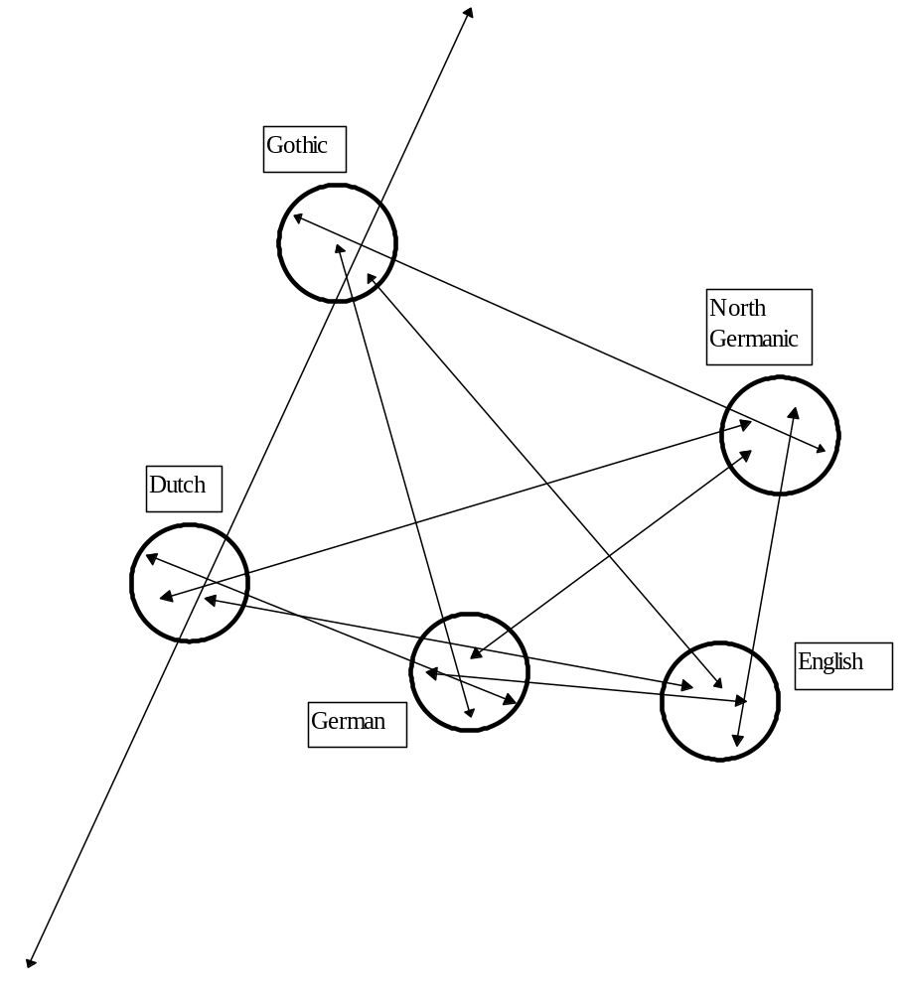
Figure 8. Graphic model of Germanic languages relationships.

but the localization of the area for the Gothic is doubtful, because the number of common words in Gothic and Dutch languages is too small. It can be explain that these possible Gothic-Dutch relationships didn’t drive the attention of scholars. There are too few Dutch examples in dictionaries of Kluge and Holthausen in general. As the localization of Gothic in the graphic model is still uncertain, this problem needs special analysis.
Since we have only four reliable nodes of graph, it is very difficult to find a proper position for the model on the map. Different variants are possible because the common number of languages is relatively small. Let’s admit such location of the model that the area of Anglos ancestors covered the former area of Italics between the Teterev, Pripyat’ and Sluch rivers, the area of modern Germans ancestors is situated in the former area of Illyrians among the Sluch, West Bug and Pripyat’ rivers. Then ancestors of modern Dutches lived in the former area of Celts and the ancestors of modern Northern Germanics had their area on the left banks of the Low Pripyat’ (see map 5).
Map 5. Map of Germanic and Iranian settlment areas
Legend: Gil - Gilanian, Kurd - Kurdish, Osset - Ossetic, Pers - Persian, Yagn - Yagnobi, Yazg - Yazgulamian.

Such location can be confirmed by connections of separate Germanic languages with Iranian languages, since the Iranian areas are already known. The comparative analysis of table-dictionaries of Germanic and Iranian languages discovered 253 Germanic-Iranian isoglosses. Northern Germanic languages have mostly Germanic Iranian lexical correspondences, to wit 193 ones. The English has a bit less, 173 correspondences, but the German has considerable lesser, only 95. The Ossetic has mostly Germanic lexical correspondences, to wit 143 correspondences. Pushtu and Kurdish have 93 correspondences, Yagnobi has 67 etc.
These data can confirm that North Germanic and Ossetic areas were once adjacent. Availability of numerous Germanisms in Ossetic has been known long ago,but linguists neglect the fact that Ossetic has the biggest number of correspondences exactly with the North Germanic languages. The area of initial formation of Proto-English was not far from the Yagnobian and Pushtu areas, therefore English should also have many common language connections with Pushtu and Yagnobian, but connections of Germanic languages with these Iranian languages are perhaps yet to be investigated. Detailed study of these connections can provide linguists with rich material for the further investigations. Yagnobian vocabulary is fairly represented in the table-dictionary because the lexical material of this language was taken from a small dictionary. Nevertheless, interesting examples of its separate correspondences to North Germanic languages and English were discovered: Swed. digna “to fall”, dingla “to hang over”– Yagn. dangal “fell”; Swed. mögel “mould” – Yagn. magor “mould”; Swed. sarg “edge” – Yagn. sarak “edge”; Eng. bug – Yagn. bugalak “gadfly”; Eng. cog – Yagn. ozax “tooth”; Eng. jump – Yagn. jumb “to move”; Eng. moth, Swed. mott, нім. Motte – Yagn. mоtta “bread moth”. Pushtu was better represented in the table therefore one can find more examples of its connections with Germanic: Eng. beam (bar)– Pushtu bena “tree”; Eng. gate – Pushtu get. “gate”; Eng. left – Pushtu lavt “weak”; Eng. mate – Pushtu mate “boar”; Eng. mitt (hand) – Pushtu met “hand”; Eng. paten (disk) – Pushtu patan “wheel of spinner”; Eng. to rate (to scold) – Pushtu ratel “to scold”; Eng. to search – Pushtu surag’ “to search”, Pers. sorag’ “to search”; Eng. spark – Pushtu speregej “spark”; Eng. wherry (boat) – Pushtu berej “boat”.
Another argument can be based on Germanic-Chuvash lexical coincidences. Evidences about language contacts between Old Bulgars and Italics were given above. When Italics moved westward, Bulgars stayed in their settlements longer and had language contacts with Germanic peoples. The evidences of mutual Germanic-Chuvash contacts can be disclosed thanks to the numerous lexical correspondences found in Germanic and Chuvash languages that are to be examined in more detail. For example, such correspondence: Chuv armuti “wormwood” – German Wermut, Engl. “wormwood”. No similarity was found in the other Indo-European languages. The German word could be derived from Western Germanic *wermóda “bitter” that has remote semantic parallel in Celtic *swerwo “bitter.” But according to the Chuvash form, Lat artemisia “wormood” is closer parallel. The Latin word could be borrowed from Old-Bulgarian with the metathesis of consonants because other Turkic languages have similar words: Tat. erem, Uzbek. erman, Yakut eberhen all “wormwood”. Thus Germanic words could be also borrowed from Old-Bulgarian. German Volk which corresponds with Eng. folk, Swedish volc is marked as “no possibility for comparison” in the same dictionary. By the way, these words may be compared with Chuv. pulkkă “flock”, “herd”. Chuv. yěkel is similar to German Eichel “acorn” which descents from Old-Germanic *aikel. Also Chuv. ătăr “otter” is similar to German Otter, Dutch, Eng. otter, Icel. otur all “otter” and Chuv. vak “ice-hole” is similar to German Wake “ice-hole”. Chuv. karta “fence” can be of Germanic origin (German Garten, Eng. garden, N. Germ. garđr from *garda), Chuv. kěrt “flock” (German Herde, Eng. herd, Sw hjord herd”, “flock” from *kerda), Chuv hütě “ shelter” (German hüten “guard, watch over”). Chuv. tu “to” (Eng. do, German to), Chuv. ühě “eagle-owl” (German Uhu “eagle owl), Chuv. haltăra “freeze” (German kalt, Eng. cold).
One must say, that the fact of the Germanic-Chuvash language connections was been already noted by the Russian scolar Kornilov. He gave some Germanic-Chuvash lexical paralleles in his work though did not explane this fact convincingly.
The Old-Bulgars covered all the steppe of the modern Ukraine and there are many reasons to associate them with Scythians. This supposition is based on linguistic and archaeological data described in detail in my recent publication.Entire pantheon of Scythian gods and Scythian mythology can be deciphered with the material of Chuvash language. The same can be said about Scythian toponymy given by Herodotus, besides some Old-Bulgarian names are used at the territory of Western Ukraine even nowadays. The comparison of Scythian onomastics with Chuvash common names is of special interest, very many names of animals can be found among them.
The reconstruction of later ethnogenic processes in Eastern Europe can be based on the analysis of Slavic languages with my method.
All the lexical material used for this study is entered into the computer as table-dictionaries and is being constantly supplemented. There still can be occasional errors or doubtful data in the tables but not to such extent that it could modify the constructed relationship models for cognate languages. The inaccuracy will be gradually reduced and available database may be used for further analyses and for the supplements and corrections of etymological dictionaries. This graphic-analytical method can be recommended for the analysis of other cognate languages as Caucasian languages and the languages of American Indians etc.

Stetsyuk V.M, Doslidzhennia peredistorychnykh etnogenetychnykh protsesiv u Skhidniy Evropi.) The Investigation of Prehistoric Ethnogenic Processes in East Europe. L’viv – Kiev (1998).
Stetsyuk V.M., Opredelenie mest poceleniya drevnikh slavian grafoanaliticheskim metodom. Izvestiya Akademii Nauk SSSR. Seriya literatury i yazyka, Tom LXIV. Nr.1.) The Determination of Settlement Territories of Ancient Slavs with Graphic-Analytical method. News of the Academy of Sciences of the USSR. Series of Literature and Language. Volume LXIV:1, Moscow (1987).
Fortunatov F.F. (Yazyk i narechiya.) “Language and Dialects.” Selected works. Moscow(1956), 68-69.
Desnitskaya A.V. Rekonstruktsiya elementov drevnebalkanskogo yazyka i obshchebalkanskiye lingvisticheskiye problemy. Pervyj kongress balkanskikh issledovateley. Reconstruction of Old-Balkanian Language Elements and General Linguistic Problems of the Balkans. The First congress of Balkan scholars, Sofia(26 August - 1 September 1966) Moscow.
5 Arapov M.V., Herts M.M. Metematicheskiye metody v istoricheskoy lingvistike. Mathematical methods in historical linguistics. Moscow (1974), 3.
Swadesh M. Leksikostatisticheskoye datirovanie doistoricheskikh etnicheskikh kontaktov. V cb. Novoye v lingvistike. Lexical-statistical Dating of Prehistoric Ethnic Contacts. The New Aspects in Linguistics (1960), 44-45.
Paul H, Printsipy istorii yazyka. The Principles of Language History. Moscow (1960), 58.
Shnirelman V.A. 1982. (Proetnos okhotnikov i sobirateley (po avstraliyskim dannym). Cb. Etnos v doklassovom i ranneclassovom obshchestve.) The Proto-ethnos of Gathers-Hunters (according to Australian data). Ethnos in Pre-class and Early-class Community. Moscow.88).
Stetsuyk, (1998), 18-20.
Meillet A. Vvedeniye v sravnitelnoye izucheniye indoevropeyskikh yazykov. Introduction to the Comparative Analysis of Indo-European Languages. Moscow-Leningrad (1938), Meillet A Sravnitelnyj metod v istoricheskom yazykoznanii Comparative Method in Historical Linguistics. Moscow (1954); Fortunatov F.F.; Gamkrelidze T.V., Ivanov V.V., (1982).
Krahe Hans. Indogermanische Sprachwissenschaft. Berlin. Einleitung und Lautlehre. (1966).
Lytkin V. I., Gulayev E.S. Kratkiy etimologicheskiy slovar’ komi yazyka. Brief Etymological Dictionary of Komi Language. Moscow(1970).
Baskakov N.A.,Tiurkskiye yazyki. Turkic Languages. Moscow(1960).
Illich-Svitych V.M. Opyt sravneniya nostraticheskikh yzykov. My Experience of Comparison of Nostratic Languages. Moscow (1971).
Andreyev N.D. Ranneindoevropeyskiy yazyk. Early-Indo- European Language Leningrad (1986).
Stetsyuk, (1998), 36.
PokornyJ., (1949-1959). Indogermanisches etymologisches Wörterbucn. Bern.
Fraenkel E. 1955-1965. Litauisches etymologisches Wörterbuch. Heidelberg.; Frisk H. 1970. Griechisches etymologisches Wörterbuch. Heidelberg; Hübschmann Heinrich. 1972. Armenische Grammatik. Erser Teil. Armenische Etymologie. Hildesheim – New York.Pokorny J. 1949-1959. Indogermanisches etymologisches Wörterbuch. Bern.; Kluge Friedrich. Etymologisches Wörterbuch der deutschen Sprache. 22 Auflage. Berlin-New York (1989).; Walde A, Lateinisches etymologisches Wörterbuch. Heidelberg (1965).
Lytkin V.I., Gulajev E.S.
Baskakov N.A., 1960, 37-60.
Sevortyan E.V. Etimologicheskiy slovar’ tyurkskikh yazykov. Etymological Dictionary of Turkic Languages. Moscow (1974).
Stetsyuk, (1998), 54-59.
Krause V. Tokharskiy yazyk. V cb. Tokharskiye yazyki. Tocharian. In the book The Tocharian Languages. Moscow (1959), 157; Gamkrelidze T.V., Ivanov V.V.Indoevropeyskiy yazyk i indoevropeytsy. Indo-European language and Indo-Europeans. Tbilisi (1984), 424; Porzig W., (1964), 315-316.
Desnitskaya A.V., 4.
StetsyuK (1998), 60-61, 67-68.
Porzig W. Chlenenije Indo-Europeyskoy yazykovoy obshchnosti. The Division of Indo-European Language Community. Moscow (1964), 159.
ib. 224.
Trubachev O.N. (Nazvaniya rek Pravoberezhnoy Ukrainy.) River Names of Right-Bank Ukraine. Moscow (1968). 279
Telegin D.Y..( Illirijskiye i frakiyskiye gidronimy Pravoberezhnoy Ukrainy v svetie arkheologichskikh issledovaniy. Voprosy yazykoznaniya.) “Illyrian and Thracian Hydronyms in the light of Archaeological Data” Problems of Linguistics, 4:1990 Moscow.
Gamkrelidze T.V., Ivanov V.V., 910.
Kapantsyan G. Istoriko-lingvisticheskiye raboty: K nachalnoy istorii armian (in Russian). Historical-linguistics works. To the primary history of Armenians. Erevan (1956), 164
Moisseyeva T.A. K voprosu o kharaktere Frigiyskogo gosudarstva v VII st. do n.e. Vestnik drevney istorii. Nr.3. To the Problem of the Character of Phrygian state in VIIth century BC. Bulletin of Ancient History, 3: 1986, 13, Moscow.
Hirt H. Die Indogermanen. Ihre Verbreituhg, ihre Urheimat und ihre Kultur. Strassburg (1905).
LEHR-SpławiNski T. (1946). O pochodzeniu i praojczyźnie Słowian. Poznań.
Stetsyuk, (1998), 62.
Telegin D.Y. Dnipro-donetska kultura. Dniepr-Donets culture. Kiev (1968),9.
ib,178.
Archaeology of Ukrainian SSR, (1985), 305.
ib, 309.
after Archaeology of Ukrainian SSR (1985) 310
Shaposhnikova O.G., Fomenko V.N., Dovzhenko N.V.(Yamnaya kulturno-istoricheskaya oblast’) The Historical Region of Pit Culture. Kiev (1986), 5.
Archeology of Ukranian SSR, (1985) 352.
ib, 350.
Archaeology of Ukrainian SSR, (1985), 337.
Menges K.H. Vostochnyje elementy v “Slove o polku Igoreve.” Oriental Elements in the Vocabulary of the Oldest Russian Epic, “The Lay of Igor’s Warfare” Leningrad (1979), 51.
Edelman D.I. (Osnovnyje voprosy lingvisticheskoy geografii. Na materiale indoiranskikh yazykov.) Basic Problems of Areal Linguistics. On the Material of Indo-Iranian Languages. Moscow (1968).
Abaev V.I. Istoriko-etimologicheskiy slovar’ osetinskogo yazyka. Historical-Etymological Dictionary of Ossetic. Moscow (1958-1989).
Stetsyuk Valentyn. (1998), 74-76.
Schmidt Wilhelm (unter Leitung). Geschichte der deutschen Sprache (1976),45.
ib.44.
Kluge Friedrich. Etymologisches Wörterbuch der deutschen Sprache. 22 Auflage. Berlin-New York (1989).;
Holthausen F. 1934. Gotisches etymologisches Wörterbuch. Heidelberg.
Abaev V.I., (1956-1989); Abaev V.I. (1965). Skifo-evropeyskiye isoglossy. Skifo- European Isoglosses. Moscow
Kluge Friedrich, (1989).
Kornilov G.E. Evraziyskiye leksicheskiye paralleli. Cheboksary. (In Russian). - Eurasian lexical parallels. Chupashkar (1973) 88-101.
Stetsyuk V.M. Do pytannia pro etnichnu prynaleyhnist skifiv. Arkheometriya 3:1999. To the Problem of the Ethnical Origin of Scythians. Archaeomerty, .3:1999, Kiev
ib.
Stetsyuk (1987)

